**Customize theme with your own fonts**

**In this tutorial, you will learn how to create a simple extension to customize your font in Qlik sense both server and desktop version.**

**Before get start, you need to have the knowledge:**

1. **Understand the basic of QlikSense Desktop/Server**
2. **Know how to install an extension in Desktop/Server**
3. **Save the font file(ttf/woff/woff2) locally**

1. Create a folder named as your theme, for example ‘GotHam_theme’

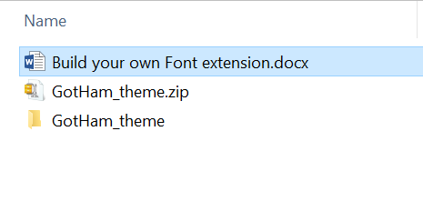

The name of the folder should be consistence with the .qext file.

1. Create your qext file, should name after the folder

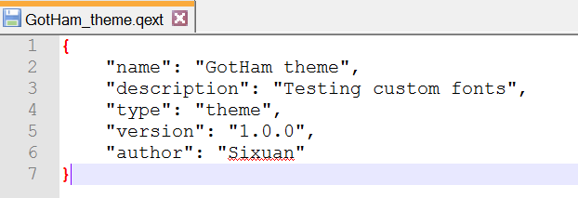

Make sure the name is same as the folder name of your extension.

1. Create your json file and name it as theme.json

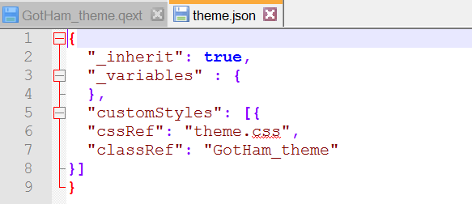

Make sure the name Ref is point to the correct file and name.

1. Create your css file and name it as theme.css
2. Put your local font(ttf/woff) into your theme folder
3. Build your local url using the link: <https://dopiaza.org/tools/datauri/index.php>

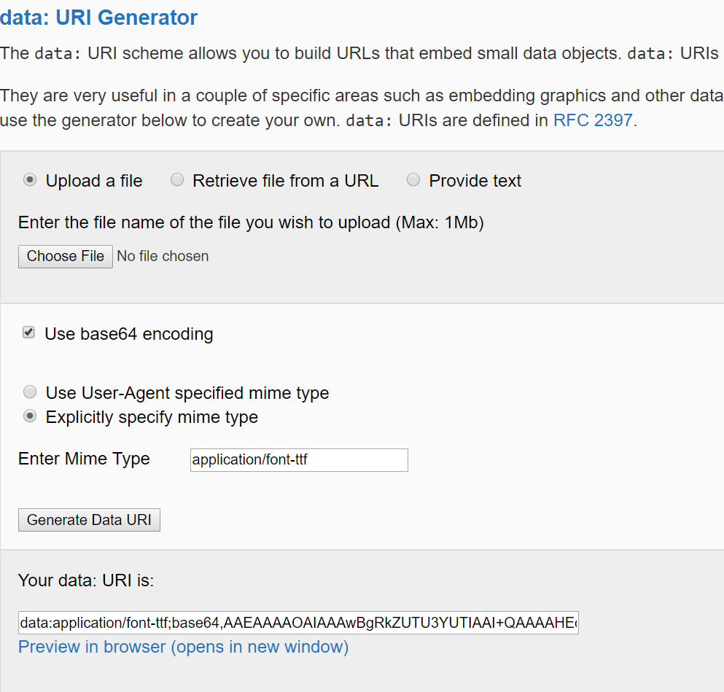

Application/font-ttf

Application/font-woff

Application/font-woff2

1. Add font url into css file

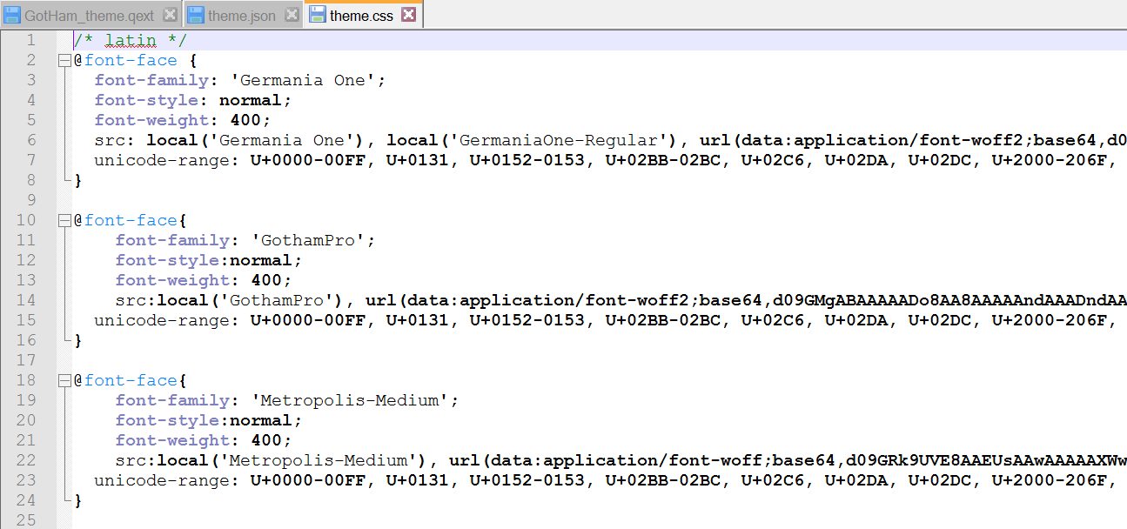

Add format type at the end of the url,

1. for ttf:

url(…) format(‘trurtype’)

2. for woff:

url(…) format(‘woff’)

1. Save all files as zip file and upload into Qlik server Extensions

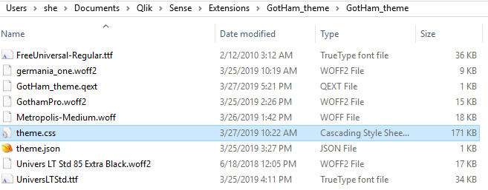

1. To apply the theme in App, please choose the theme in app settings

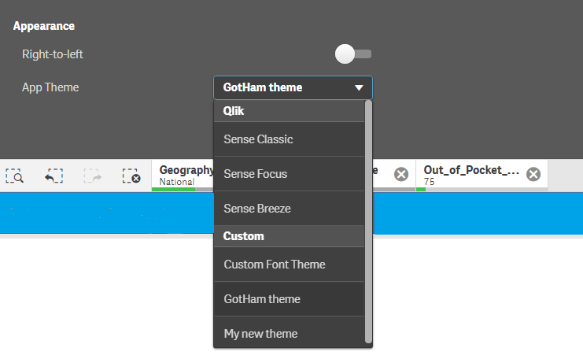

1. To apply the theme in App using Vizlib, please choose ‘define your own’ in font family and type your customized font name as below:

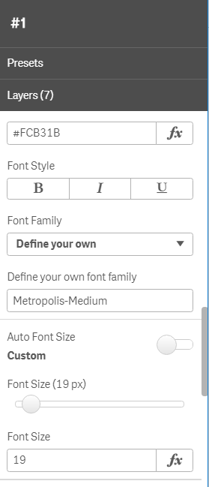

Typing the name of the font you created here.